

**- Faculty of Computer and Information Sciences –**

**- AIN Shams University -**

**HCI - SC**

**-----------------------------------------------------------**

**ECG-BASED-AUTHENTICATION-INTERFACE**

**TEAM INFROMATION: SC-14**

|  |  |  |
| --- | --- | --- |
| **القسم** | **رقــــم الجلوس** | **الأســـــــم** |
| **SC** | **20191700221** | **خالد احمد عبدالظاهر محمد** |
| **SC** | **20191700029** | **احمد خالد احمد عبداللاه** |
| **SC** | **20191700034** | **احمد سعيد نوح ابراهيم** |
| **SC** | **20191700040** | **احمد طارق فتحى محمد** |

**- Under Supervision -**

**Dr. Manal Tantawi**

**TA. Manar Sultan**

**Main idea**

Ecg-Based-Authentication-Interface that can recognize Authorized Persons from its ECG After result from Classifier based on fiducial and non-fiducial features extracted from Signal ..

ECG signals have 11 main points differ from person to each other ..

**Dataset**

We used ECG-ID Database The ECG-ID Database is a set of 310 ECGs from 90 volunteers, created and contributed to PhysioBank by Tatiana Lugovaya and Published: March 6, 2014.

The records were obtained from volunteers (44 men and 46 women aged from 13 to 75 years who were students, colleagues, and friends of the author). The number of records for each person varies from 2 (collected during one day) to 20 (collected periodically over 6 months).

The raw ECG signals are rather noisy and contain both high and low frequency noise components. Each record includes both raw and filtered signals:

* Signal 0: ECG I (raw signal)
* Signal 1: ECG I filtered (filtered signal)

**In Our Project** we selected Raw signal with noise to can apply Feature Extraction on it from PERSON_01,PERSON_02,PERSON_52 and PERSON_72 “ lot numbers of records “

Figure - PERSON1 RECORD 1

Figure - PERSON2 RECORD 11

**Data preparation**

**READ DATA:**

Records was in types of “.atr , .dat , .hea”, so we used **wfdb.rdsamp** method in **wfdb** library that take location of all signals and range of samples from 0 to “Specific Range=1500” and number of channels “ in case our data [ 0:”raw”,1:”filitered”] “

And we when read data we take Label of all signals to can Encoding it before submit to classifier.

Before Classifying, we split data into 80% Training and 20% Testing.

**PREPROCESSING:**

due to noise in raw signals

1. Non fiducial features: Firstly using butter bandpass filter with parameters   
   - low cutoff:1.0 Hz , High cutoff:40.0 Hz , samplingRate = 500.0 and order = 4  
   - smoothing signal   
   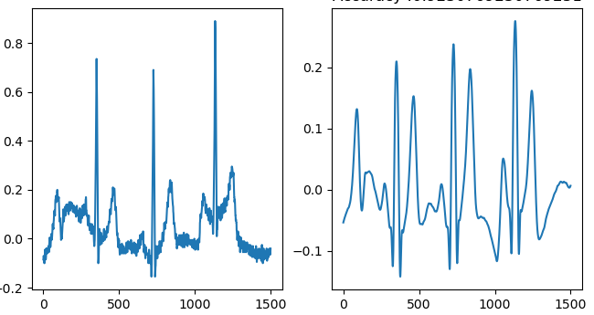
2. Fiducial Features: must apply butter bandpass filter in steps of Pan and Tompkins with parameters  
   - low cutoff:1.0 Hz , High cutoff:40.0 Hz , samplingRate = 500.0 and order = 1  
   A graph with blue lines and red dots

   Description automatically generated with low confidence

**Feature Extraction**

1. **Non-fiducial:**Applying Autocorrelation to get segments and then apply DCT to reduce Dimension of signal  
   A picture containing text, diagram, line, plot

   Description automatically generated  
   300 samples as segment from AC because another is aliasing to first Heartbeat ,then take first 100 features from DCT to Classifier to train .
2. **Fiducial:** we need to extract main 11 points from each heartbeat, so we applied Pan and Tompkins that first search for R Peaks  
   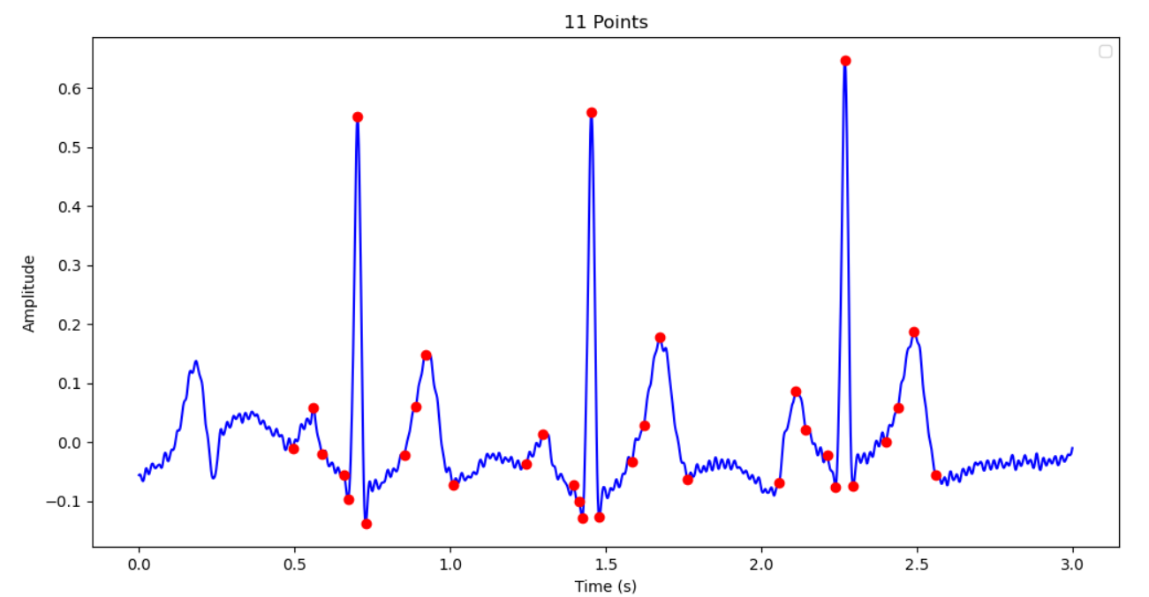  
   and from each R peaks we search for P,Q,S,T local Maximum and minimum windows before and after everyone + **specific Range we entered=50** and for onset or offset for each Point, we used get_point_with_max_area() function in Helpers to find point with max Area in **specific Range we entered.  
     
     
     
   Calculating 21 Features From Extracted Points**–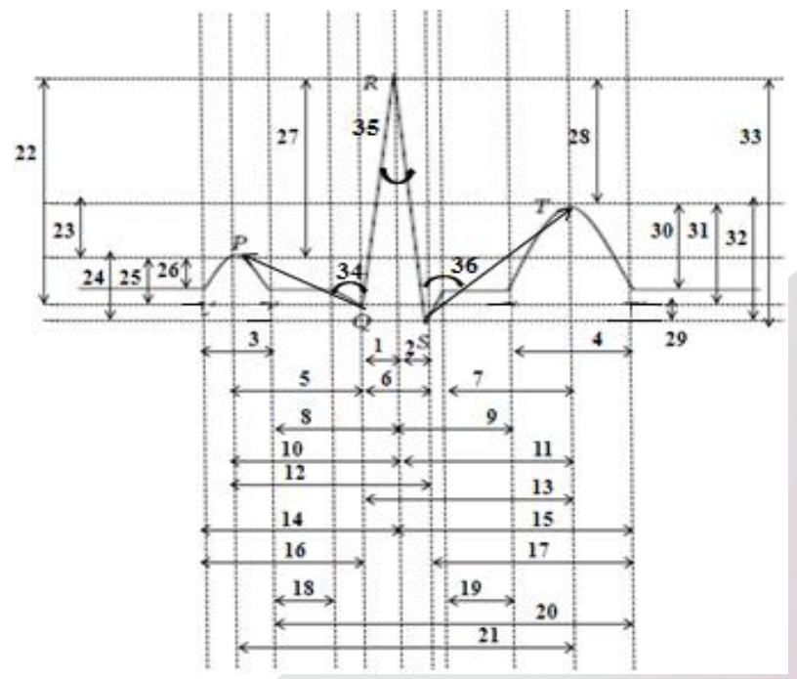

Figure - Features From 1 to 21

**Classification**

**We Used SVM Classifier with Parameters** *clf = svm.SVC(kernel='poly',degree=3, C=1)* after training we Get Good Results from it that lead to not change parameters

|  |  |  |
| --- | --- | --- |
| TYPES OF FEATUERS | NO. OF INPUT FEATUERS | ACCURACY |
| Non-Fiducial | Array of 100 | 100.00% |
| Fiducial | Array of 42 | 91.66% |

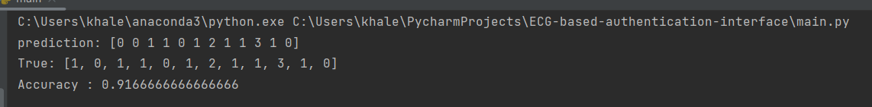

Figure – Fiducial

Figure – non – Fiducial

**Interface**

From interface we take  
- Signal from Persons Authorized and not authorized,  
 *PERSON_01, PERSON_02 🡪 Authorized  
 PERSON_03, PERSON_10 🡪 Not Authorized*  
- Type of Features which need to test using it.

And display if Person Authorized or not authorized and Accuracy of Model Trained Before..

First State – Waiting information from User.

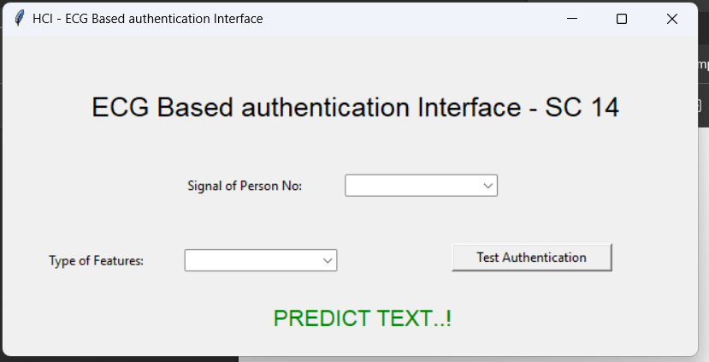

If there empty information, Console will print 

**IN CASE “ Fiducial “**

**IN CASE “ Non - Fiducial “**

